1. Choose “Conference” for -Select Payment Type-

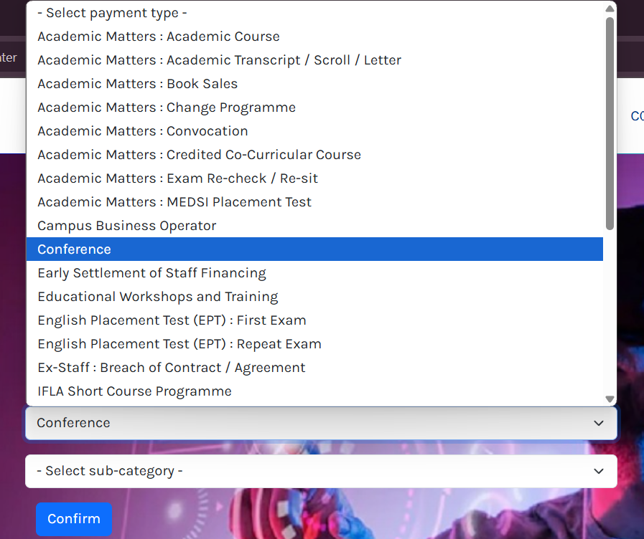

1. Choose “7th ICEPEE 2025” for -Select sub-category-

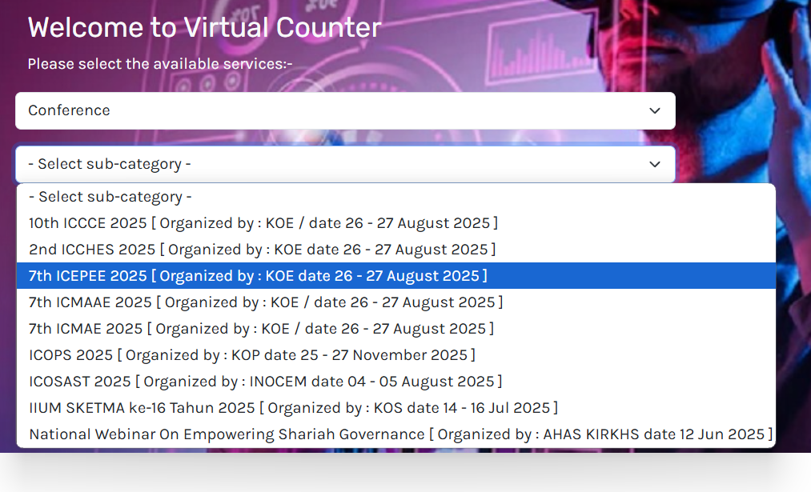

1. You may “Login” if you already have an account with Ezpay (if you’re IIUM Staff or student). Or choose “Register Now” to create an account. Else, you may choose “Proceed without registration”

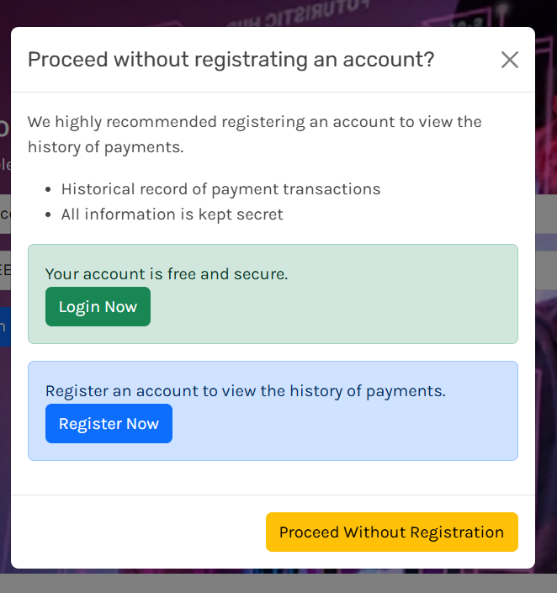

1. If you choose “Login now’, Select “Virtual Counter”.

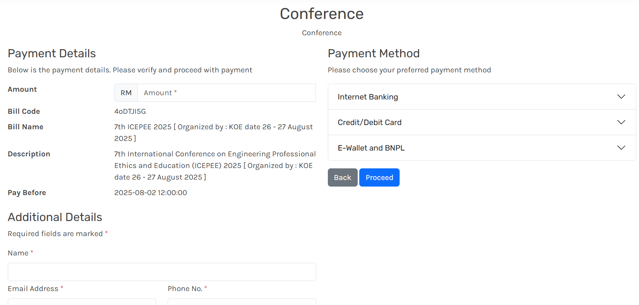

1. Fill in all details. Click “Proceed”